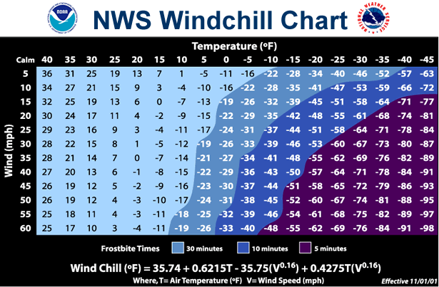

[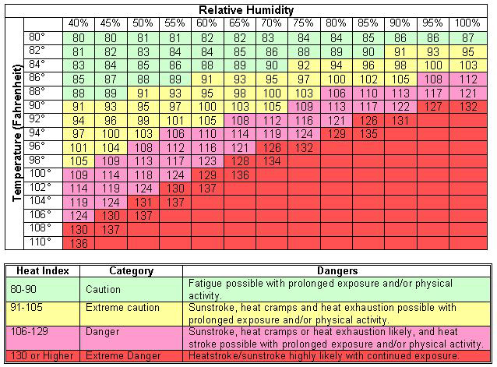](http://www.google.com/url?sa=i&rct=j&q=heat+stress+chart&source=images&cd=&docid=dUgZpChB42qmxM&tbnid=y2Uomxd2fWCI6M:&ved=0CAUQjRw&url=http%3A%2F%2Fehs.iupui.edu%2Foccupational-safety.asp%3Fcontent%3Dheat-stress-prevention&ei=_TgIUa_7PITuqAH_sYCwDg&bvm=bv.41524429,d.aWM&psig=AFQjCNFoIGS0oiEpOUmGtPEb0y-on3Vfhg&ust=1359579774496118)