Reference Guide for Contractor/Grantee Performance Evaluations

In this guide you will find instructions for finding the Contractor/Grantee Performance Evaluation eForm, as well as information about what to enter in the form fields. A Frequently-Asked Questions page can be found at the end of the guide. If you have additional questions or need assistance, contact Johanna Fierke at [johanna.fierke@state.mn.us](mailto:johanna.fierke@state.mn.us), or the Help Desk.

Finding a new eform

From an email (workflow notification):Once your contract/grant is done, you will be notified via workflow that it is time to fill out a performance evaluation for a contractor/grantee. The workflow will send an email with a link to the evaluation eform in OnBase. Clicking on the link will open the eform.

From Microsoft Outlook: The eform can be found in the OnBase menu in the ribbon at the top of the application. Click on “Forms”, and select Contractor/Grantee Evaluation from the list on the left.

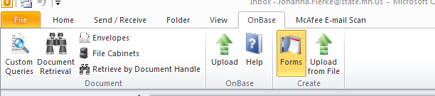

In the OnBase13 Unity Client:The form is located under “Forms”. In the sidebar, either scroll down or search “evaluation” to find the link labelled “Contractor/Grantee Evaluation”. For help finding the OnBase Unity Client, click [here](https://nerd.pca.state.mn.us/onbase) to go to The Lorax.

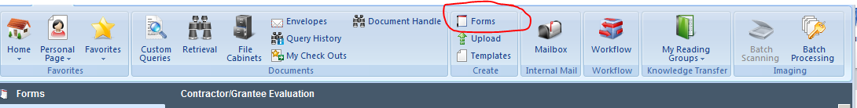

Keyword Definitions and Usage

In order for Contractor/Grantee Performance Evaluations to be retrieved easily from OnBase, it is important that there is consistency with how the form fields are completed. Below is a list of form fields (also called “keywords”) and dates that are requested for this workflow; their definitions; and the preferred format for submission. Entering the CR number (if available) will autocomplete most of the other form fields.

|  |  |  |  |  |  |
| --- | --- | --- | --- | --- | --- |
| **Form field** | **Definition** | **Input Format** | **Example** | **Where to Find** | **Value Autofills from CR# entry??** |
| **Contract Request Number (CR#)** | A unique number generated by the MPCA’s Contract Routing Database, and given to identify any contract, grant or RFP | All digits of the 3-5 digit number (no letters) | 3996 (not CR3996) | Bottom left-hand corner of contract/ grant | No- CR# entry prompts autofill |
| **SWIFT Contract ID\*** | A unique number generated by SWIFT to identify a contract or grant. Format: A long string of zeros, followed by 5 numbers | All digits, NOT including zeros | 25667  (not 0000000000000000000025667) | Upper right-hand corner of contract/grant | Yes |
| **PO Number** | Purchase order number: a unique number generated by SWIFT to identify a purchase order. Format: the number 3 followed by several zeros and between 3 and 6 numbers | All digits, including 3 and zeros (no letters) | 3000010255 | Upper right corner of contract/ work order | Yes |
| **TEMPO Project Profile ID** | A unique project number generated by TEMPO | TBD | TBD | TBD | Yes |
| **Contractor/ Grantee Name** | The business or entity awarded a contract or grant | Exactly as listed in the contract/grant (no additional abbreviations, etc.) | Barr Engineering, Inc. | The first paragraph of the contract/grant | Yes |
| **Contract/Grant start date** | The date the contract/grant was executed | MM/DD/YYYY | 6/31/2015 | The latest signature date found on the signature [last] page of the contract/grant. | Yes |
| **Evaluation date** | The date the evaluation was completed (usually today’s date) | MM/DD/YYYY | 6/31/2015 | OnBase auto suggestion | No |
| **Original contract/grant end date** | The original end date of the contract | MM/DD/YYYY | 6/31/2015 | On the **original** contract (usually in the first clause on the first page) | Yes |
| **Actual contract/grant end date** | Same as above, unless the project time has been extended by an amendment | MM/DD/YYYY | 6/31/2015 | On the **most recent amendment**, if changes have been made | Yes |
| **Amendment Number** | The number of amendments to the contract/grant **including** the upcoming amendment | Numerical form, starting with the **upcoming** amendment. Counting starts from 1, not 0. | 2 | On the **most recent amendment**, if changes have been made | Yes |

|  |  |  |  |  |  |
| --- | --- | --- | --- | --- | --- |
| **Form field** | **Definition** | **Input Format** | **Example** | **Where to Find** | **Value Autofills from CR# entry??** |
| **Original contract/grant value** | The original value of the contract | $DDDD.CC  (no commas) | $2000.00 | On the **original** contract | Yes |
| **Total value of amendments** | The total value of all amendments to date | $DDDD.CC  (no commas) | $700.00 [one amendment worth $200.00, plus one amendment worth $500.00] |  | Yes |
| **Total value to date** | The total value of the contract to date, including all amendments | $DDDD.CC  (no commas) | $3700.00 [original contract value of $2000.00, plus total amendment value of $700.00) | On the **most recent amendment**, if changes have been made | Yes |
| **Evaluation Type** | **AMENDMENT**: Any evaluation for an **active contract or grant**. This evaluation is required before requesting an amendment.  **GRANT:** once grant has expired, a final evaluation for a **grant** worth any amount**  **FINAL EQUAL/ OVER$25,000**: Once contract is done, a final evaluation for a **contract** worth less than, or equal to, $25,000 (including amendments)*  **FINAL UNDER $25,000**: Once contract has expired, a final evaluation for a **contract** worth more than $25,000 (including amendments)* | | | | No |

* If there are multiple amendments or change orders associated with a CR#, the “Select Dataset” popup window will display.  Scroll to the right on that window and click the “Select” button on the bottom row in the list to populate the eform values.

**These distinctions are important because MPCA leadership requires an evaluation prior to an amendment to document that work is satisfactory and worthy of continuing on. Department of Administration requires additional information for contracts over >$25,000, so by selecting this option, the questions are slightly different. Office of Grants Management policies also require grantee evaluations in order to inform future grant creation.

FAQ

How does autofill work?

Entering the CR number + tab will automatically populate some of the fields on the General Information tab for most contracts/grants in the CR database. **If the CR number does not auto-populate information on the General Information tab, or if the contract/grant/work order does not have a CR number, the required data will need to be entered manually**.

Will the SWIFT number autofill any information?

No, entering the SWIFT number will not populate any fields.

What if my contract/grant/work order doesn’t have a CR number?

If the contract/grant/ work order has no CR number, enter 0000 as the CR number so that the form can be submitted. The rest of the required data will need to be entered manually.

What if my contract/grant/work order doesn’t have a PO number?

If the contract/grant/ work order has no PO associated with it, enter 0000000000 as the PO number so that the form can be submitted.

Can I save the form and come back to it later?

The Contractor/Grantee Performance Evaluation **cannot** be saved while “in progress”. In other words, the form is only saved when it is submitted. Whoever is submitting the evaluation should make sure they have all the information they need before starting the evaluation. Once started, the form should only take a few minutes to complete.

*Tip: Take a look at the form to see what information is required before filling out the evaluation.*

I submitted my form, but I realized that I made a mistake. Can I go back and fix it?

Yes you can! All you need to do is retrieve the form, either from Document Retrieval or from a Custom Query in OnBase. Once you have opened the saved form, you may make changes. Be sure to click the “Submit” button at the bottom when you are done. Guidance for how to retrieve a document can be found at [The Lorax](https://nerd.pca.state.mn.us/onbase).

I filled out the form from an email or Lorax link, and the webpage went blank after I clicked “submit”. Did my form go through?

This is normal. The link pulls up a version of the evaluation form in your web browser, which works the same way as the form in the Unity Client or the Outlook extension. However, the browser window is just *displaying* the OnBase form. Once you click submit, the browser has nothing left to display because the form has been sent back to OnBase.  If you want to double-check that your form has been successfully stored in OnBase, do a custom query for your own name (Last, First) under “Find by person importing document”. For more specific instructions, see the OnBase guidance on the Lorax.

I tried to submit my form, but I got an error message. What do I do?

Required fields are designated with an asterisk. Make sure to fill out information for ALL tabs before submitting. If you do not enter anything in one or more of these fields, the missing information will be highlighted in red.

Below is an example:

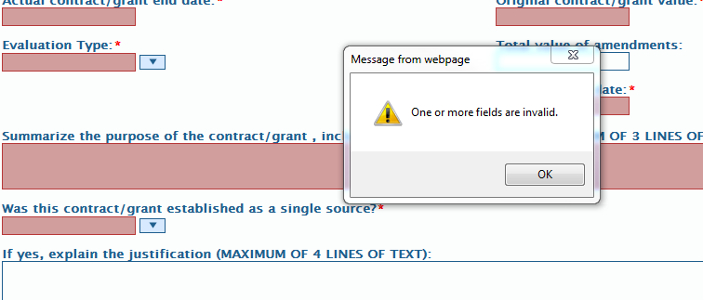

In most cases, filling in all required information will fix the problem. However, if you have data in all of the required fields and are still getting an error message, contact the Help Desk to alert OnBase staff to the issue. Take screenshots of the evaluation form if you can’t attend to the issue immediately; then you will be able to enter the information quickly at a later time.