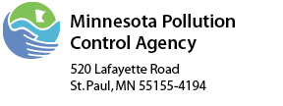 | Closed Landfill Program  Field Notes

Site Name: | Freeway |  | Date: |  | 2/14/18
Personnel: | Dan McNamara

Time period on site:
From: | 1030 | To: |  | 1130

Reason for Site Visit:

To get readings/inspection of gas probes on US Salt property.

Weather conditions (temperature, wind, precipitation, etc.):

30 F, Clear, 5-10 S, BP-29.83 ↓

Site Notes
Site Activities:
Check in with US Salt staff upon entering site.
Used Envision Meter, serial # 1506201
Annual Factory Calibration on 9/14/17
Successful field calibration
Gas Probe Readings/Inspection
-Locks on Gas Probes are 3438.
-Lubricated locks with WD-40. Getting rusty from salt.
-No issues found on gas probe inspection.

