Sample text within the main body:

Targeting and Prioritization of Geographic Areas

Summary

As threats to Minnesota’s watersheds continue to mount, it is becoming increasingly important to identify and conserve high-priority areas. Identification of these priority areas, including sources of point and non-point pollution, will be crucial for targeting actions to improve water quality. There are multiple opportunities for protection or restoration in any watershed. Identifying which practices to implement and where in the landscape to implement them can help more effectively target efforts and more efficiently utilize limited resources.

To prioritize land within the Mississippi River –Grand Rapids watershed, we used a process that included the values-based model Zonation. This process began with the identification of the goals of the watershed and concluded with a review of the results. The identification of priority areas was based on the quantitative analysis (using Zonation) of a suite of data layers. Planning team members decided on what landscape features were included in the model and set the weights on those features via a pairwise questionnaire survey. The process was framed within the DNR’s healthy watershed conceptual model, and included biology, hydrology, water quality, geomorphology, and connectivity components. An additional component, designed to capture “unique resources” within the watershed was also included.

This approach recognized that attempts to solve clean water needs within the watershed are not separate from other natural resource needs; each priority area should provide multiple benefits. The model used in this process helps achieve this goal by identifying areas that provide multiple benefits while incorporating data valued by the community.

See Appendix X for details on methods.

Results

The pairwise questionnaire survey results identified the Protect/Restore Unique Resources component of the value model inputs as the highest weight, followed by Protect/Improve Fish & Wildlife Habitat. The Protect/Improve Lands of Concern component was assigned the lowest weight (Figure 1 and Table 2).

The Zonation model was run using the weights derived from the questionnaire. The Zonation output map ranked lands as to their importance for land management activities that would provide greater protection of ecosystem functions, especially water quality, and to their importance for application of various land best management practices.

The priority map identified several priority areas. High rankings were given to lands near the city of Cromwell. Lands within the catchments surrounding Big Sandy Lake also ranked high. Near Hill City, the riparian areas of Morrison Brook as well as lands to the southeast of the city were identified as high priority areas. High priority rankings were also given to lands near the city of Grand Rapids, as well as near Trout and Swan Lakes (Figures 2 and 3).

The results of a second survey regarding “Watershed Activities” identified Improve Technical Assistance & Incentive Programs, Protect/Restore Riparian Vegetation, and Improve Education, Outreach, & Civic Engagement as the three most important activities for this watershed (Figure 4). Activities with the lowest preference included protecting areas with conservation easements or acquisition.

Appendix X.
Description of Methods
By Paul J. Radomski and Kristin Carlson

Methods

Values-based models, such as Zonation, are an efficient method for prioritizing places on the landscape for protection or restoration of water resources. These models integrate individual landscape features with context and connections, and use an objective function to identify priority resource areas. The use of an additive benefits (i.e., multiple benefits) objective function in the value model allows for the inclusion of multiple landscape features. Value models also lend themselves to collaborative efforts, by providing an opportunity for participants to decide what features are valued and the ranking of those valued features. In addition, value models and the DNR five-component healthy watershed model used to structure the content in the value model are simple concepts that are easy to explain and apply at the local government scale. Value models do not provide guidance on what practices should be implemented where, so additional analysis and/or discussion on effective and appropriate best management practices will be necessary when project planning.

The first step of the four-step process involved determining which features should be included in the Zonation model. The WRAPS team decided on 28 features (i.e., data layers), grouped within six components (Table 1). Data for the Culturally valuable lands feature were not available, so this feature was excluded from analysis. Each data layer was on the same grid with a resolution of 30 by 30m. We used high-resolution data to maximize local planning realism and for greater practicality in local government water resource planning and implementation.

Weights were used to identify which features were valued more. Within the five-component healthy watershed framework, for example, water quality features could be weighted higher than biological features. The feature-specific weights used in Zonation were set using the analytic hierarchy process (AHP; Saaty and Peniwati 2007). A hierarchical survey (components → features) comprised of pairwise comparisons was used to identify the preferences of a diverse group of individuals within the watershed. Each individual taking the survey used his or her judgment about the relative importance of all survey elements. The relative importance values included “equal,” “prefer,” and “strongly prefer.” Individual responses were aggregated with a geometric mean, and the pairwise comparison matrix was constructed to compute the feature-specific weights consistent with the AHP.

The value models were developed using Zonation software (Moilanen et al. 2009). Zonation produces a nested hierarchy of spatial priorities. It begins with the full landscape and iteratively removes cells that contribute least to the objective; therefore, the removal order is the reverse order of the priority ranking. Zonation assumes that the full watershed is available for consideration. In these models, the lakes were masked out prior to analysis. This focused the prioritization on the terrestrial parcels, in accordance with the protection and restoration goals of the Mississippi River – Grand Rapids watershed. Zonation’s algorithms seek maximal retention of weighted normalized landscape features.

To produce a map that identified areas on the landscape that provide multiple benefits, we used the additive benefit function within Zonation. This function aggregates values by summation across features:

V(P) = Σw_{j}N_{j}(P)^{z}_{j}

where the value of a parcel V(P) is equal to the summation of weighted w normalized features of the parcel N_{j}(P) to the power of z (set to 0.25 for all features).

Additionally, Zonation allows ranking to be influenced by neighboring parcels, so that highly valued areas can be aggregated, and fragmentation of areas can be minimized. We utilized the distribution-smoothing algorithm in Zonation, which assumes that fragmentation (low connectivity) generally should be avoided for all features. Initial analyses indicated that a connectivity distance of 200m may be appropriate for local government efforts targeted at the watershed scale. We found that very small connectivity distances made no difference in prioritization, since the connectivity effect did not extend very far, and very large connectivity distances aggregated cells across unrealistically large areas. We also found that across a modest range of connectivity distances the results were minor.

In addition, a survey was provided to citizens and civic leaders to identify their preferences about potential stewardship activities within the watershed.

References

Moilanen, A., H. Kujala, and J. Leathwick. 2009. The Zonation framework and software for conservation prioritization. Pages 196-210 in A. Moilanen, K. A. Wilson, and H. P. Possingham, editors. Spatial conservation prioritization: quantitative methods and computational tools. Oxford University Press, Oxford, UK.

Saaty, T.L., and K. Peniwati. 2007. Group decision-making: Drawing out and reconciling differences. Pittsburgh, PA: RWS Publications.

Table 1. Descriptions for features (i.e., data layers) used in land prioritization value models.

Objective | Description
Protect or Improve Waters of Concern
Focus on Impaired waters | Catchments (i.e., drainage basins) upstream of aquatic life impaired lakes within the watershed. Identified as impaired by the Minnesota Pollution Control Agency (MPCA).
Focus on Catchments with high pollution | Estimated total suspended solids, total nitrogen, and total phosphorus by catchment as determined by hydrological models. Source: MPCA HSPF model.
Focus on Catchments of lakes with declining water quality | Lakes where long-term data suggest declining water quality.
Focus on Catchments of lakes vulnerable to nutrient addition | The relative susceptibility of a lake to phosphorus pollution (based on lake morphology and catchment hydrology). Source: Lakes of phosphorus sensitivity significance (MPCA and DNR).
Protect or Restore Shoreland | Land within 1000 feet of lake shoreline.
Focus on Catchments with altered hydrology | In small watersheds or catchments with greater than 60% open land or covered with young trees there is marked increase in runoff rates. Source: based on USDA Forest Service research of Sandy Verry; Mitch Brinks’s analysis.

Reduce Erosion & Runoff
Focus on Areas with high erosive potential | Stream Power index: This is an index of the channelized flow erosive potential. Calculated from LiDAR data.
Focus on Areas close to water | Lands close to a stream and lake are more valuable in the protection of water quality than those farther away. The data are the inverse distance from water.
Protect Existing priority wetlands | Existing wetlands as documented by the National Wetland Inventory (NWI) classified using methods from Aitkin County SWCD.
Protect or Restore Stream riparian areas | Stream riparian areas and potential flood zones (based on location, elevation and soil type).
Reduce Soil erosion risk | Susceptibility of soils to erosion. This variable is from the BWSR and UMN’s Environmental Benefits Index; it was calculated from a subset of the universal soil loss equation.

Protect or Improve Fish & Wildlife Habitat
Protect or Restore Trout streams | DNR designated trout stream riparian and floodplain areas.
Protect Sites of biodiversity significance | Areas with varying levels of native biodiversity that may contain high quality native plant communities, rare plants, rare animals, and/or animal aggregations. Identified by Minnesota Biological Survey.
Protect or Restore Sensitive lakeshore | Lakeshore areas that provide unique or critical ecological habitat. Protocols for identifying these areas were developed by the DNR.
Protect High value forests | MDNR designated high conservation value forests due to plant and animals present and DNR designed old-growth forests.

Protect Unique Resources
Protect or Restore Lakes of biological significance | Catchments of high quality lakes. List of high quality lakes based on dedicated biological sampling. Includes wild rice lakes, cisco lakes, high quality fish waters, and other unique lakes. Source: DNR.
Protect or Restore Ecological connections | Ecological corridors between generally large, intact, native or “semi-natural” terrestrial habitat patches. Source: DNR.
Protect or Restore Culturally valuable lands | Cultural lands valuable to citizens of the watershed.
Protect Rare features | Locations of species currently tracked by the DNR, including Endangered, Threatened, and Special Concern plant and animal species as well as animal aggregation sites.

Protect Groundwater
Protect Groundwater of private wells in sensitive areas | Geologic sensitivity based on the Minnesota Well Index. Source: Minnesota Department of Health (MDH).
Focus on Drinking Water Supply Management Area (DWSMA) vulnerability | The risk associated with potential contaminant sources within a public water supply DWSMA to contaminate its drinking water supply. This risk is based on the aquifer's inherent geologic sensitivity, the assessed vulnerability of the public water supply well(s), and the composition of the groundwater. In highly vulnerable DWSMAs, there is a strong causal relationship between land use activities on the surface and groundwater quality. Includes Source Water Assessment Areas as designated by MDH.
Focus on Groundwater contamination susceptibility | The relative susceptibility of an area to groundwater contamination (based on geologic stratigraphy, aquifer transmissivity, and recharge potential).
Focus on Areas with high groundwater recharge | Estimated potential groundwater recharge. About 75% of drinking water and 90% of agricultural irrigation water in Minnesota are supplied from groundwater. The water that is withdrawn must be supplied by some combination of (1) increased recharge, (2) decreased discharge to streams, lakes, and other surface-water bodies, and (3) removal of water that was stored in the system. Source: U.S. Geological Survey, in cooperation with the MPCA.

Protect or Improve Forestry, Agricultural, and other Lands of Concern
Implement BMPs on Pasture/hay | Land cover type is pasture or hay (areas used for livestock grazing or planted with perennial seed or hay crops).
Implement BMPs on Cultivated croplands | Land cover type is cultivated crops (areas used for the production of annual crops or actively tilled areas).
Implement BMPs on Valuable timber lands | Forest lands that have been identified as important.
Protect Lands close to protected lands | Lands close to protected lands may be more important for conservation, as larger, contiguous areas often have more value than smaller, fragmented lands. The data are the inverse distance to existing protected lands.
Protect or Improve Lands in Urban growth or Agricultural conversion areas | Lands identified more likely to be developed, and some of these lands that provide important ecosystem services may be of conservation value. Source: Mitch Brinks’s analysis of land conversion risk and inverse distance to urban areas.
Table 2. Component and feature weights used in the Zonation model. Weights were obtained from a questionnaire using the analytic hierarchy process (AHP; weights sum to 100).

Component (broad-scale) Prioritization | Weight | Weight Used in Model
Protect/Improve Waters of Concern | 17.3
Reduce Erosion & Runoff | 15.6
Protect/Improve Fish & Wildlife Habitat | 17.7
Protect/Restore Unique Resources | 19.2
Protect Groundwater | 16.1
Protect/Improve Lands of Concern | 14.1
Feature (fine-scale) Prioritization
Impaired waters | 11 | 1.8
Catchments with higher pollution | 16 | 2.7
Lakes with declining water quality | 18 | 3.2
Catchments of lakes vulnerable to nutrient loading | 19 | 3.3
Shoreland | 24 | 4.1
Catchments with high altered hydrology | 13 | 2.2
Areas with high erosive potential | 15 | 2.3
Areas close to water | 22 | 3.4
Existing wetlands | 18 | 2.8
Stream riparian areas | 32 | 5.0
Soil erosion risk | 14 | 2.2
Trout stream catchments | 20 | 3.6
Sites of biodiversity significance | 24 | 4.2
Sensitive lakeshore | 30 | 5.3
High value forests | 26 | 4.6
Lakes of biological significance | 44 | 8.5
Ecological connections | 34 | 6.5
Rare features | 22 | 4.2
Groundwater of private wells | 19 | 3.1
Drinking water supply mgt areas | 19 | 3.1
Groundwater contamin. suscept. | 31 | 5.0
Areas with high groundwater recharge | 30 | 4.9
Figure 1. The component (broad-scale) weights used in the Zonation model. Weights were obtained from a questionnaire using the analytic hierarchy process (AHP; weights sum to 100).

Figure 2. Priority map from Zonation analysis.

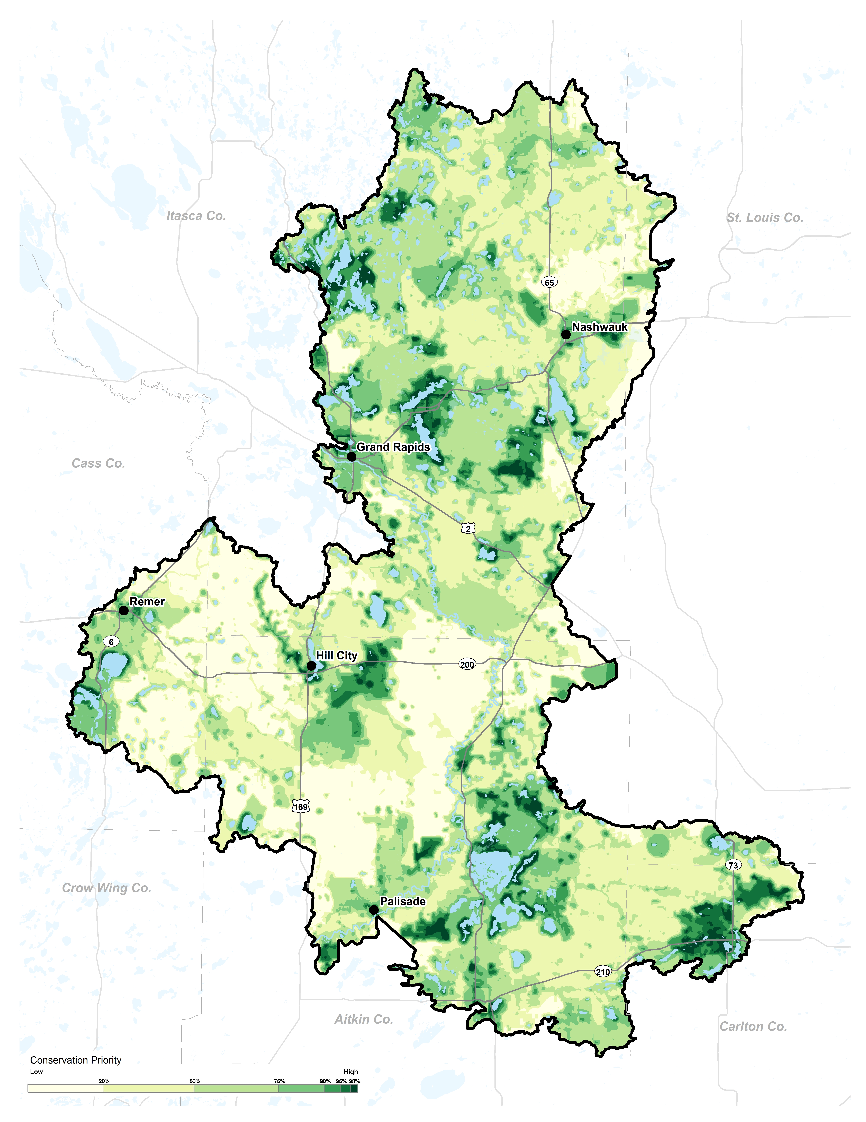

Figure 3. Priority map from Zonation analysis and land ownership.

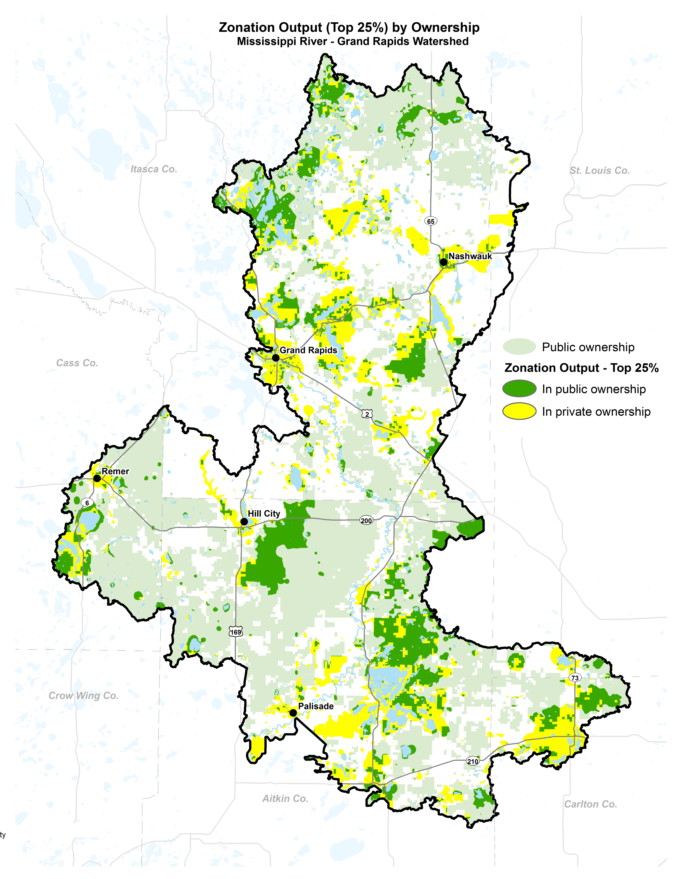

Figure 4. Results from survey used to identify preferences about watershed activities.

